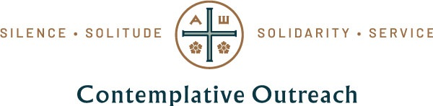

Community Conversation Guide
Please email a one-page summary of your conversation to story@coutreach.org by July 15. You are also welcome to submit a photo or short video that captures a highlight or special message from your group. If you have any question, or wish to request translated guides, please email story@coutreach.org.
+++
Conversation Host: (name, e-mail, phone #)

Name and location of participating Centering Prayer Community (e.g., online 12-Step Outreach prayer group based in St. Louis, U.S.A.)
Number of people attending:
Conversation Questions:
- What? What events or activities are currently happening in your Centering Prayer community? Please be as specific as possible, e.g., number of Centering Prayer groups or retreats happening or planned for this year; approximate number of people participating, whether groups are meeting online or in person, etc.

- So What? What difference do you think these activities are making in the development of contemplative practice and the process of transformation in your community? Please consider both the positive and negative differences you have observed, for example: new connections made and/or connections lost; deepened practice or less time for personal prayer, etc.

- Now What? Recalling Fr. Thomas final words to us in 2018 – "… We are called to start, not with the old-world contract … but with what we know is the truth", use your answers to questions 1 and 2 to reflect on the following questions:
  - What is working well in your community that you would like to continue?
  - What is not serving you well that might you need to let go of?
  - What is emerging for you in your sense of vision for your group and/or for Contemplative Outreach as a whole?
  - What additional supports might be needed to help your community live into this vision?

